# Angular

**Materials and resources:**

<https://angular.io/docs>

<https://cli.angular.io/>

<https://www.dunebook.com/from-zero-to-hero-learn-angularstrap-from-scratch/>

<http://www.netinstructions.com/100-days-of-angular-2/?utm_source=mybridge&utm_medium=web&utm_campaign=read_more>

<https://github.com/johnpapa/angular-styleguide/blob/master/a2/README.md>

<https://legacy.gitbook.com/book/basarat/typescript/details>

<https://basarat.gitbooks.io/typescript/>

<https://www.youtube.com/watch?v=qRD7bkK7m10>

<https://thinkster.io/tutorials/learn-angular-2>

<https://www.tutorialspoint.com/angular2/>

Books: ng-book2-r37

**Assignments:**

### Task 1: Implement ‘Admin: Product list page’

List Products

All products in the system are listed in table same as the following mockup.

Search Products

On top of the table, there is a search field that is searching products by name. When the user enters some word in the input search bar and clicks ‘Search’ only products that contain word entered in the input field are displayed in the table.

Delete Product

When a user clicks on delete button on the same product confirm dialog is open with a text ‘Are you sure you want to perform this action?’ and two buttons ‘Yes’ and ‘Cancel’. When user select ‘Yes’ button product is deleted and removed from the table. When user clicks on ‘Cancel’ button confirm dialog is closed.

Pagination

In the table should be listed only 10 items. On click on next page should be listed next 10 items.

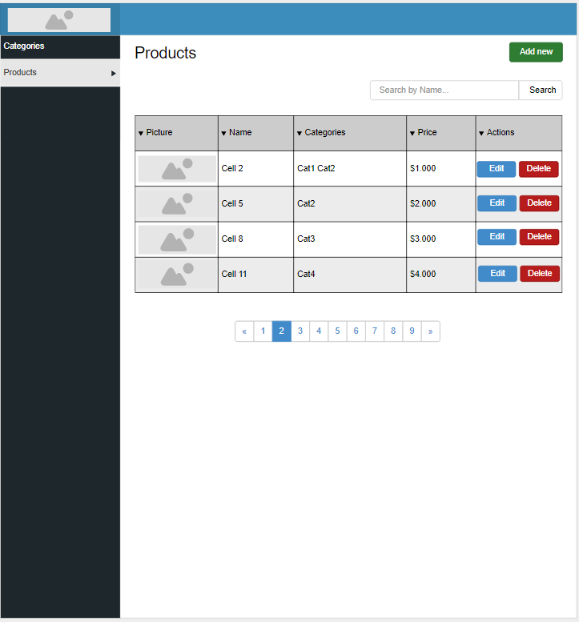

Admin: Product list page

### Task 2: Implement Portal layout

Implement following layout (logo, navbar, design, colors etc.)

